**L4 - Connect to the AWS EC2 Ubuntu Instance and Update default packages, install JDK, Maven,Git, and validate the versions**

**Step 1: Launch EC2 Instance**

1. **Sign in to AWS Console** 
   * **Go to AWS Management Console**
   * **Navigate to EC2 service**

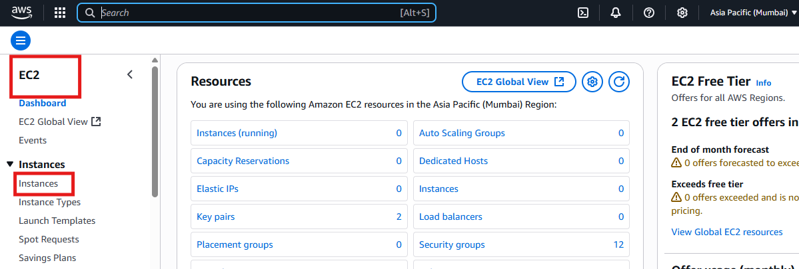

**2.Launch Instance**

* **Click "Launch Instance"**
* **Choose "Ubuntu Server"**
* **Select instance type (t2.micro for free tier)**
* **Choose key pair**

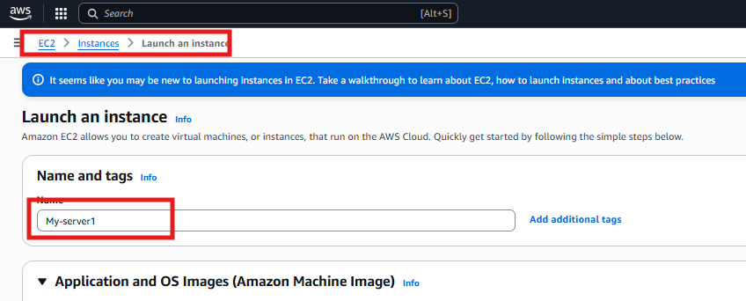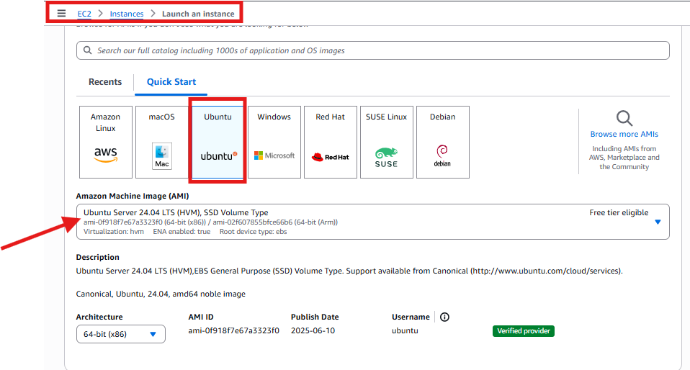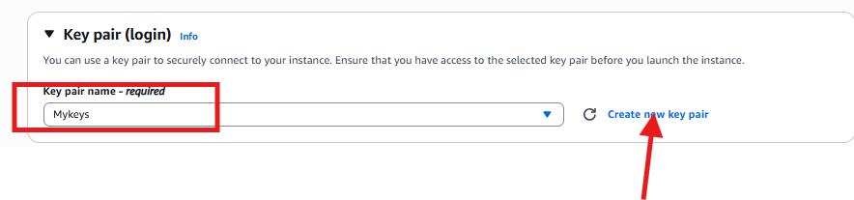

**3.under Network Setting**

**Create a security group or select existing security group**

**Click on Allow SSH traffic from and Allow HTTP traffic from the Internet**

**Configure storage to be kept as default and click on launch instance**

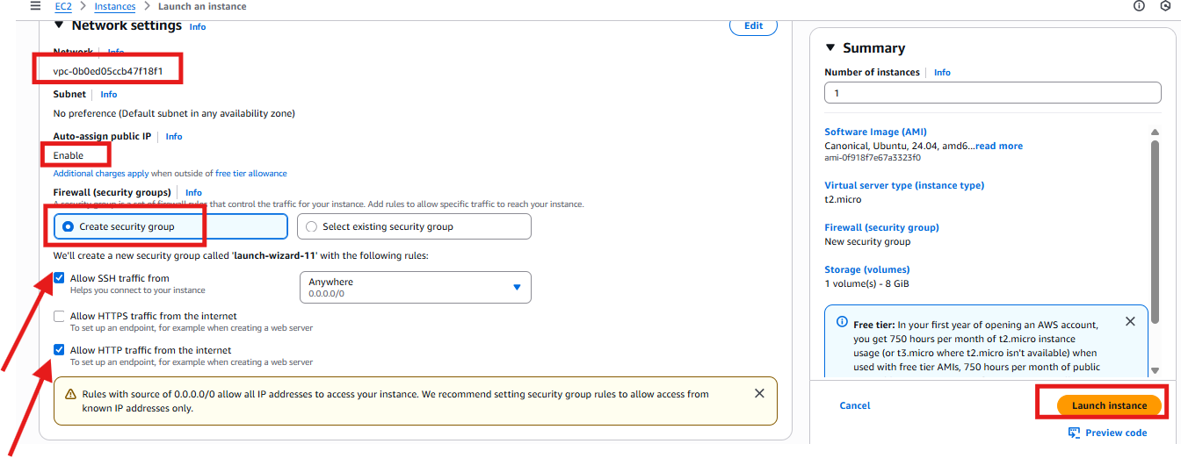

**4. Connect to the instance using SSH:**

**\*Use putty to connect to instance -enter the hostname or IP and use the new key pair installed on local machine for authentication to connect to instance**

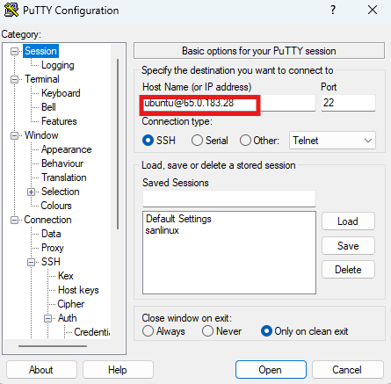

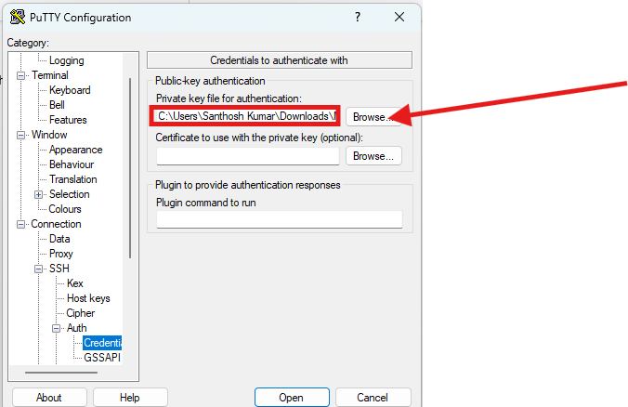

**5.** **Update Default Packages**

**sudo apt update**

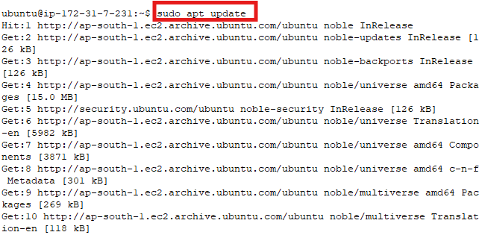

**6. Install Java Development Kit (JDK)**

**sudo apt install openjdk-11-jdk -y**

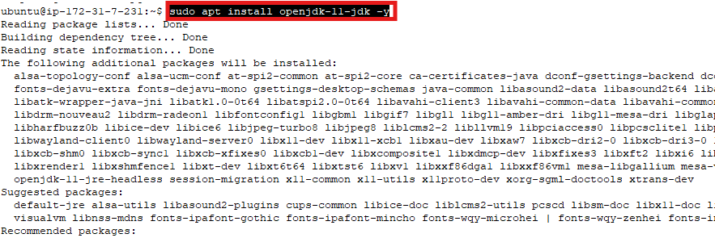

**7.** **Install Apache Maven**

**sudo apt install maven -y**

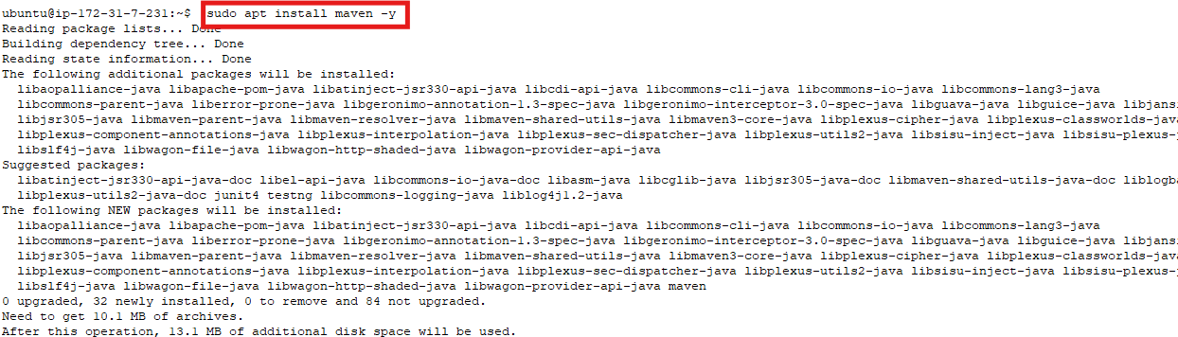

**8.** **Install Git**

**sudo apt install git -y**

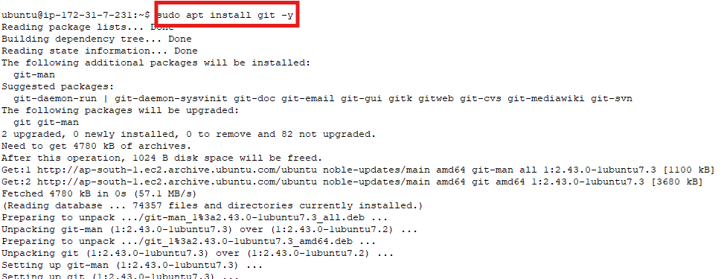

**9.Validate the versions**

**sudo java –version**

**sudo mvn –version**

**sudo git --version**